**Assignment 4: Text and Sequence:**

Steven Kalinoff  
4/07/2024

Adv. Machine Learning 64061

Baseline performance

Top 150 words 100 samples

from tensorflow.keras.datasets import imdb

(train_data, train_labels), (test_data, test_labels) = imdb.load_data(

    num_words=150)

Embedding Layer @ 150/100

from tensorflow import keras

from tensorflow.keras import layers

max_tokens = max([max(sequence) for sequence in train_data]) + 3

embedding_layer = layers.Embedding(input_dim=max_tokens, output_dim=256)

inputs = keras.Input(shape=(None,), dtype="int64")

embedded = layers.Embedding(input_dim=max_tokens, output_dim=256)(inputs)

x = layers.Bidirectional(layers.LSTM(32))(embedded)

x = layers.Dropout(0.5)(x)

outputs = layers.Dense(1, activation="sigmoid")(x)

model = keras.Model(inputs, outputs)

model.compile(optimizer="rmsprop",

              loss="binary_crossentropy",

              metrics=["accuracy"])

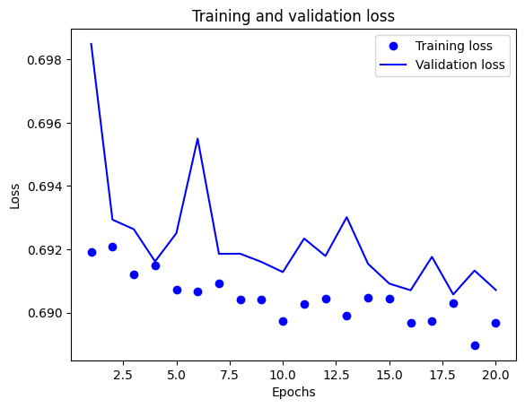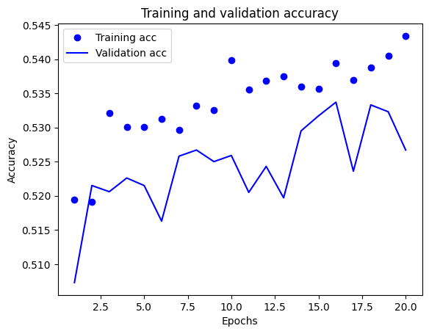

Pretrained word embedding

#pretrained

import tensorflow_hub as hub

text_vectorization = TextVectorization(

    ngrams=2,

    max_tokens=20000,

    output_mode="multi_hot",

)

import numpy as np

path_to_glove_file = "glove.6B.100d.txt"

embeddings_index = {}

with open(path_to_glove_file) as f:

    for line in f:

        word, coefs = line.split(maxsplit=1)

        coefs = np.fromstring(coefs, "f", sep=" ")

        embeddings_index[word] = coefs

print(f"Found {len(embeddings_index)} word vectors.")

from tensorflow import keras

from tensorflow.keras import layers

